ICS 321 project

Team 32

MOHAMMED SHARAF ALJOUDI

  202041460

DB snapshot : 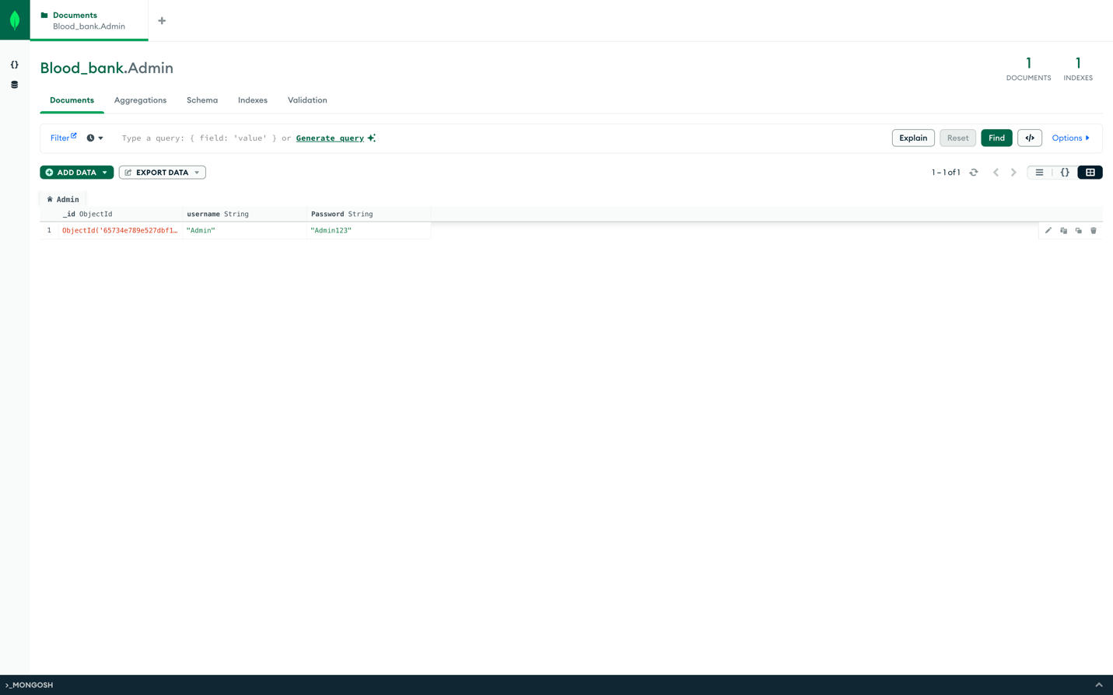

Github repository: <https://github.com/Liloiscracked/Blood-Bank-System>